3223600019

Muhammad Bimo Fachrizky

Membuat Aplikasi Deep Learning tensorflow 2

Senin, 05 Mei 2025

**Praktikum Sistem Cerdas**

**Praktikum 10**

Membuat Aplikasi Deep Learning tensorflow 2

1. Tujuan Pembelajaran

* Mahasiswa dapat memahami dan menjelaskan konsep Deep Learning
* Mahasiswa dapat menjelaskan model Deep Learning
* Mahasiswa dapat membuat aplikasi Deep Learing tensorflow

Software yang di perlukan

* Microsoft Visual C++
* PyCharm

1. Langkah percobaan
2. Listing 2.3. fashion_classifier_with_callback.py

import tensorflow as tf

class MyCallback(tf.keras.callbacks.Callback):

def on_epoch_end(self, epoch, logs=None):

if logs.get("accuracy") > 0.6:

print("\nReached 60% accuracy so cancelling training!")

self.model.stop_training = True

if __name__ == "__main__":

# Load the dataset

mnist = tf.keras.datasets.fashion_mnist

(x_train, y_train), (x_test, y_test) = mnist.load_data()

# Normalize the data

x_train, x_test = x_train / 255.0, x_test / 255.0

# Initialize the callback

callbacks = MyCallback()

# Build the model

model = tf.keras.models.Sequential([

tf.keras.layers.Flatten(input_shape=(28, 28)),

tf.keras.layers.Dense(512, activation=tf.nn.relu),

tf.keras.layers.Dense(10, activation=tf.nn.softmax)

])

# Compile the model

model.compile(

optimizer=tf.optimizers.Adam(),

loss="sparse_categorical_crossentropy",

metrics=["accuracy"]

)

# Train the model

model.fit(x_train, y_train, epochs=10, callbacks=[callbacks])

1. Listing 2.4. fashion_classifier_with_cnn.py

import tensorflow as tf

import matplotlib.pyplot as plt

import numpy as np

def create_cnn_model():

mnist = tf.keras.datasets.fashion_mnist

(training_images, training_labels), (test_images, test_labels) = mnist.load_data()

training_images = training_images.reshape(-1, 28, 28, 1) / 255.0

test_images = test_images.reshape(-1, 28, 28, 1) / 255.0

model = tf.keras.models.Sequential([

tf.keras.layers.Conv2D(64, (3, 3), activation="relu", input_shape=(28, 28, 1)),

tf.keras.layers.MaxPooling2D(2, 2),

tf.keras.layers.Conv2D(64, (3, 3), activation="relu"),

tf.keras.layers.MaxPooling2D(2, 2),

tf.keras.layers.Flatten(),

tf.keras.layers.Dense(128, activation="relu"),

tf.keras.layers.Dense(10, activation="softmax")

])

model.compile(

optimizer="adam",

loss="sparse_categorical_crossentropy",

metrics=["accuracy"]

)

model.summary()

model.fit(training_images, training_labels, epochs=10)

test_loss = model.evaluate(test_images, test_labels)

return model, test_loss

def visualizing_conv_and_max_pool(model):

mnist = tf.keras.datasets.fashion_mnist

(_, _), (test_images, test_labels) = mnist.load_data()

test_images = test_images.reshape(-1, 28, 28, 1) / 255.0

print(test_labels[:100].reshape(10, 10))

f, ax_arr = plt.subplots(3, 4, figsize=(10, 10))

first_image = 0

second_image = 28

third_image = 23

convolution_number = 2 # Nomor filter (0–63)

layer_outputs = [layer.output for layer in model.layers]

activation_model = tf.keras.models.Model(inputs=model.layers[0].input, outputs=layer_outputs)

for x in range(4):

f1 = activation_model.predict(test_images[first_image].reshape(1, 28, 28, 1))[x]

ax_arr[0, x].imshow(f1[0, :, :, convolution_number], cmap="inferno")

ax_arr[0, x].grid(False)

f2 = activation_model.predict(test_images[second_image].reshape(1, 28, 28, 1))[x]

ax_arr[1, x].imshow(f2[0, :, :, convolution_number], cmap="inferno")

ax_arr[1, x].grid(False)

f3 = activation_model.predict(test_images[third_image].reshape(1, 28, 28, 1))[x]

ax_arr[2, x].imshow(f3[0, :, :, convolution_number], cmap="inferno")

ax_arr[2, x].grid(False)

plt.tight_layout()

plt.show()

if __name__ == "__main__":

cnn_model, cnn_test_loss = create_cnn_model()

cnn_model.save("model-saved/category2.h5")

visualizing_conv_and_max_pool(cnn_model)

1. Listing 2.5. face_expression_classifier_with_cnn.py

import os

import zipfile

import numpy as np

import tensorflow as tf

import matplotlib.pyplot as plt

import matplotlib.image as mpimg

from tensorflow.keras.optimizers import Adam

from tensorflow.keras.preprocessing.image import ImageDataGenerator

from tensorflow.keras.preprocessing import image as keras_image

class MyCallback(tf.keras.callbacks.Callback):

def __init__(self, desired_accuracy):

super(MyCallback, self).__init__()

self.DESIRED_ACCURACY = desired_accuracy

def on_epoch_end(self, epoch, logs=None):

if logs is None:

logs = {}

if logs.get("accuracy") > self.DESIRED_ACCURACY:

print(f"\nReached {self.DESIRED_ACCURACY * 100:.2f}% accuracy so cancelling training!")

self.model.stop_training = True

def load_dataset(zip_file_path, extracted_zip_file_path, train_happy_dir, train_sad_dir):

if not os.path.exists(extracted_zip_file_path):

os.makedirs(extracted_zip_file_path, exist_ok=True)

zip_ref = zipfile.ZipFile(zip_file_path, "r")

zip_ref.extractall(extracted_zip_file_path)

zip_ref.close()

train_happy_names = os.listdir(train_happy_dir)

train_sad_names = os.listdir(train_sad_dir)

print(train_happy_names[:10])

print(train_sad_names[:10])

print(f"Total training happy images: {len(train_happy_names)}")

print(f"Total training sad images: {len(train_sad_names)}")

return train_happy_names, train_sad_names

def do_data_preprocessing(dataset_dir):

train_datagen = ImageDataGenerator(rescale=1./255, validation_split=0.2)

train_generator = train_datagen.flow_from_directory(

dataset_dir,

target_size=(150, 150),

batch_size=8,

class_mode="binary",

subset='training'

)

validation_generator = train_datagen.flow_from_directory(

dataset_dir,

target_size=(150, 150),

batch_size=8,

class_mode="binary",

subset='validation'

)

return train_generator, validation_generator

def create_cnn_model():

model = tf.keras.models.Sequential([

tf.keras.layers.Conv2D(16, (3, 3), activation="relu", input_shape=(150, 150, 3)),

tf.keras.layers.MaxPooling2D(2, 2),

tf.keras.layers.Conv2D(32, (3, 3), activation="relu"),

tf.keras.layers.MaxPooling2D(2, 2),

tf.keras.layers.Conv2D(64, (3, 3), activation="relu"),

tf.keras.layers.MaxPooling2D(2, 2),

tf.keras.layers.Flatten(),

tf.keras.layers.Dense(512, activation="relu"),

tf.keras.layers.Dense(1, activation="sigmoid")

])

model.compile(

loss="binary_crossentropy",

optimizer=Adam(learning_rate=0.001),

metrics=["accuracy"]

)

model.summary()

return model

def plot_training_images(train_happy_dir, train_sad_dir, train_happy_names, train_sad_names):

plt.figure(figsize=(16, 16))

img_index = 0

next_happy_img = [os.path.join(train_happy_dir, fname) for fname in train_happy_names[img_index:img_index + 8]]

next_sad_img = [os.path.join(train_sad_dir, fname) for fname in train_sad_names[img_index:img_index + 8]]

for i, img_path in enumerate(next_happy_img + next_sad_img):

plt.subplot(4, 4, i + 1)

plt.axis("off")

img = mpimg.imread(img_path)

plt.imshow(img)

plt.tight_layout()

plt.show()

def classify_images(fn_arr, model):

for fn in fn_arr:

path = os.path.join("datasets", fn)

if not os.path.exists(path):

print(f"File not found: {path}")

continue

img = keras_image.load_img(path, target_size=(150, 150))

x = keras_image.img_to_array(img)

x = np.expand_dims(x, axis=0)

x /= 255.0 # Normalize the image

prediction = model.predict(x)

print(f"Prediction score for {fn}: {prediction[0][0]}")

if prediction[0] > 0.5:

print(f"{fn} is happy")

else:

print(f"{fn} is sad")

if __name__ == "__main__":

# Konfigurasi path

base_dir = "datasets"

zip_file_path = os.path.join(base_dir, "happy-or-sad.zip")

extracted_zip_file_path = os.path.join(base_dir, "happy-or-sad")

train_happy_dir = os.path.join(extracted_zip_file_path, "happy")

train_sad_dir = os.path.join(extracted_zip_file_path, "sad")

# Load dataset

train_happy_names, train_sad_names = load_dataset(

zip_file_path, extracted_zip_file_path,

train_happy_dir, train_sad_dir

)

plot_training_images(train_happy_dir, train_sad_dir, train_happy_names, train_sad_names)

train_generator, validation_generator = do_data_preprocessing(extracted_zip_file_path)

cnn_model = create_cnn_model()

DESIRED_ACCURACY = 0.99

callbacks = MyCallback(DESIRED_ACCURACY)

history = cnn_model.fit(

train_generator,

steps_per_epoch=train_generator.samples // train_generator.batch_size,

validation_data=validation_generator,

validation_steps=validation_generator.samples // validation_generator.batch_size,

epochs=50,

verbose=1,

callbacks=[callbacks]

)

test_images = [

"beauty-1132617_640.jpg",

"girl-2961959_640.jpg",

"woman-2126727_640.jpg",

"beautiful-18279_640.jpg"

]

classify_images(test_images, cnn_model)

1. Listing 3.1. cats_and_dogs_classifier_with_cnn.py

import os

import zipfile

import numpy as np

import random

import matplotlib.pyplot as plt

import matplotlib.image as mpimg

import tensorflow as tf

from tensorflow.keras.optimizers import Adam

from tensorflow.keras.preprocessing.image import ImageDataGenerator, img_to_array, load_img

from tensorflow.keras.preprocessing import image as keras_image

def load_dataset(zip_file_path, extracted_zip_file_path):

zip_ref = zipfile.ZipFile(zip_file_path, "r")

zip_ref.extractall(os.path.split(extracted_zip_file_path)[0])

zip_ref.close()

train_dir = os.path.join(extracted_zip_file_path, "train")

validation_dir = os.path.join(extracted_zip_file_path, "validation")

train_cats_dir = os.path.join(train_dir, "cats")

train_dogs_dir = os.path.join(train_dir, "dogs")

validation_cats_dir = os.path.join(validation_dir, "cats")

validation_dogs_dir = os.path.join(validation_dir, "dogs")

train_cat_fnames = os.listdir(train_cats_dir)

train_dog_fnames = os.listdir(train_dogs_dir)

validation_cat_fnames = os.listdir(validation_cats_dir)

validation_dog_fnames = os.listdir(validation_dogs_dir)

print(train_cat_fnames[:10])

print(train_dog_fnames[:10])

print("total training cat images :", len(train_cat_fnames))

print("total training dog images :", len(train_dog_fnames))

print("total validation cat images:", len(validation_cat_fnames))

print("total validation dog images:", len(validation_dog_fnames))

return train_dir, validation_dir, train_cats_dir, train_dogs_dir, train_cat_fnames, train_dog_fnames

def do_data_preprocessing(train_dir, validation_dir):

train_datagen = ImageDataGenerator(rescale=1. / 255)

validation_datagen = ImageDataGenerator(rescale=1. / 255)

train_generator = train_datagen.flow_from_directory(

train_dir,

batch_size=20,

class_mode="binary",

target_size=(150, 150)

)

validation_generator = validation_datagen.flow_from_directory(

validation_dir,

batch_size=20,

class_mode="binary",

target_size=(150, 150)

)

return train_generator, validation_generator

def create_cnn_model():

inputs = tf.keras.Input(shape=(150, 150, 3))

x = tf.keras.layers.Conv2D(16, (3, 3), activation="relu")(inputs)

x = tf.keras.layers.MaxPooling2D(2, 2)(x)

x = tf.keras.layers.Conv2D(32, (3, 3), activation="relu")(x)

x = tf.keras.layers.MaxPooling2D(2, 2)(x)

x = tf.keras.layers.Conv2D(64, (3, 3), activation="relu")(x)

x = tf.keras.layers.MaxPooling2D(2, 2)(x)

x = tf.keras.layers.Flatten()(x)

x = tf.keras.layers.Dense(512, activation="relu")(x)

outputs = tf.keras.layers.Dense(1, activation="sigmoid")(x)

model = tf.keras.Model(inputs=inputs, outputs=outputs)

model.summary()

model.compile(optimizer=Adam(learning_rate=0.001),

loss="binary_crossentropy",

metrics=["accuracy"])

return model

def plot_cats_and_dogs(train_cats_dir, train_dogs_dir, train_cat_fnames, train_dog_fnames):

nrows, ncols = 4, 4

fig = plt.gcf()

fig.set_size_inches(ncols * 4, nrows * 4)

pic_index = 8

next_cat_pix = [os.path.join(train_cats_dir, fname) for fname in train_cat_fnames[pic_index - 8:pic_index]]

next_dog_pix = [os.path.join(train_dogs_dir, fname) for fname in train_dog_fnames[pic_index - 8:pic_index]]

for i, img_path in enumerate(next_cat_pix + next_dog_pix):

sp = plt.subplot(nrows, ncols, i + 1)

sp.axis("off")

img = mpimg.imread(img_path)

plt.imshow(img)

plt.pause(0)

def classify_images(fn_arr, model):

for fn in fn_arr:

path = os.path.join("datasets", fn)

img = keras_image.load_img(path, target_size=(150, 150))

x = keras_image.img_to_array(img)

x = np.expand_dims(x, axis=0)

image_i = np.vstack([x])

classes = model.predict(image_i, batch_size=10)

print(classes[0])

if classes[0] > 0.5:

print(fn + " is a dog")

else:

print(fn + " is a cat")

def plot_intermediate_repr(model, train_cats_dir, train_dogs_dir, train_cat_fnames, train_dog_fnames):

successive_outputs = [layer.output for layer in model.layers]

visualization_model = tf.keras.models.Model(inputs=model.input, outputs=successive_outputs)

cat_img_files = [os.path.join(train_cats_dir, f) for f in train_cat_fnames]

dog_img_files = [os.path.join(train_dogs_dir, f) for f in train_dog_fnames]

img_path = random.choice(cat_img_files + dog_img_files)

img = load_img(img_path, target_size=(150, 150))

x = img_to_array(img)

x = x.reshape((1,) + x.shape) / 255.

successive_feature_maps = visualization_model.predict(x)

layer_names = [layer.name for layer in model.layers]

for layer_name, feature_map in zip(layer_names, successive_feature_maps):

if len(feature_map.shape) == 4:

n_features = feature_map.shape[-1]

size = feature_map.shape[1]

display_grid = np.zeros((size, size * n_features))

for i in range(n_features):

x = feature_map[0, :, :, i]

x -= x.mean()

x = x / x.std() if x.std() > 1e-14 else x

x = np.clip(x * 64 + 128, 0, 255).astype("uint8")

display_grid[:, i * size:(i + 1) * size] = x

plt.figure(figsize=(20, 2))

plt.title(layer_name)

plt.grid(False)

plt.imshow(display_grid, aspect="auto", cmap="viridis")

plt.subplots_adjust(left=0.03, right=0.99)

plt.pause(0)

def plot_history(train, val, title):

epochs = range(len(train))

plt.figure()

plt.plot(epochs, train, label="train")

plt.plot(epochs, val, label="val")

plt.title(title)

plt.legend(loc="best")

plt.pause(0)

if __name__ == "__main__":

zip_file_path = "datasets/cats_and_dogs_filtered.zip"

extracted_zip_file_path = "datasets/cats_and_dogs_filtered"

train_dir, validation_dir, train_cats_dir, train_dogs_dir, train_cat_fnames, train_dog_fnames = load_dataset(

zip_file_path, extracted_zip_file_path)

plot_cats_and_dogs(train_cats_dir, train_dogs_dir, train_cat_fnames, train_dog_fnames)

train_generator, validation_generator = do_data_preprocessing(train_dir, validation_dir)

cnn_model = create_cnn_model()

history = cnn_model.fit(

train_generator,

validation_data=validation_generator,

steps_per_epoch=100,

epochs=15,

validation_steps=50,

verbose=1

)

fn_arr = [

"cat-2083492_only_head.jpg",

"cat-1146504_640.jpg",

"dog-3846767_640.jpg",

"dog-3388069_640.jpg"

]

classify_images(fn_arr, cnn_model)

plot_intermediate_repr(cnn_model, train_cats_dir, train_dogs_dir, train_cat_fnames, train_dog_fnames)

acc = history.history["accuracy"]

val_acc = history.history["val_accuracy"]

loss = history.history["loss"]

val_loss = history.history["val_loss"]

plot_history(acc, val_acc, "Training and validation accuracy")

plot_history(loss, val_loss, "Training and validation loss")

1. Listing 3.2. cats_and_dogs_classifier_with_imagedatagen_and_dropout.py

import os

import numpy as np

import matplotlib.pyplot as plt

import tensorflow as tf

from tensorflow.keras import layers

from tensorflow.keras.optimizers import Adam

from tensorflow.keras.preprocessing import image as keras_image

# Constants

IMG_HEIGHT = 150

IMG_WIDTH = 150

BATCH_SIZE = 20

# Plot training history

def plot_history(train, val, title):

epochs = range(len(train))

plt.figure()

plt.plot(epochs, train, label="train")

plt.plot(epochs, val, label="val")

plt.title(title)

plt.legend(loc="best")

plt.show()

# Create CNN model

def create_cnn_model(input_shape=(150, 150, 3)):

model = tf.keras.models.Sequential([

tf.keras.layers.Input(shape=input_shape),

tf.keras.layers.Conv2D(32, (3, 3), activation="relu"),

tf.keras.layers.MaxPooling2D(2, 2),

tf.keras.layers.Conv2D(64, (3, 3), activation="relu"),

tf.keras.layers.MaxPooling2D(2, 2),

tf.keras.layers.Conv2D(128, (3, 3), activation="relu"),

tf.keras.layers.MaxPooling2D(2, 2),

tf.keras.layers.Conv2D(128, (3, 3), activation="relu"),

tf.keras.layers.MaxPooling2D(2, 2),

tf.keras.layers.Dropout(0.5),

tf.keras.layers.Flatten(),

tf.keras.layers.Dense(512, activation="relu"),

tf.keras.layers.Dense(1, activation="sigmoid")

])

model.compile(

loss="binary_crossentropy",

optimizer=Adam(learning_rate=1e-4),

metrics=["accuracy"]

)

model.summary()

return model

# Classify individual images

def classify_images(fn_arr, model):

for fn in fn_arr:

path = os.path.join("datasets", fn)

if not os.path.exists(path):

print(f"Warning: File {path} not found.")

continue

img = keras_image.load_img(path, target_size=(150, 150))

x = keras_image.img_to_array(img)

x = np.expand_dims(x, axis=0) / 255.0

prediction = model.predict(x)

print(f"File: {fn}, Prediction score: {prediction[0][0]}")

if prediction[0][0] > 0.5:

print(f"{fn} is a dog")

else:

print(f"{fn} is a cat")

# Build augmentation pipeline

def build_augmentation_pipeline(img_height, img_width):

data_augmentation = tf.keras.Sequential([

layers.RandomFlip("horizontal", input_shape=(img_height, img_width, 3)),

layers.RandomRotation(factor=0.11, fill_mode="nearest"),

layers.RandomZoom(height_factor=0.2, width_factor=0.2, fill_mode="nearest"),

layers.RandomTranslation(height_factor=0.2, width_factor=0.2, fill_mode="nearest")

])

return data_augmentation

# Image preprocessing

def process_path(file_path):

img = tf.io.read_file(file_path)

img = tf.io.decode_image(img, channels=3, expand_animations=False)

img = tf.image.resize(img, [IMG_HEIGHT, IMG_WIDTH])

return img

# Dataset configuration

def configure_for_performance(ds, shuffle=False, augment=False):

ds = ds.cache()

if shuffle:

ds = ds.shuffle(buffer_size=1000)

ds = ds.batch(BATCH_SIZE)

if augment:

augmentation_pipeline = build_augmentation_pipeline(IMG_HEIGHT, IMG_WIDTH)

ds = ds.map(lambda x, y: (augmentation_pipeline(x, training=True), y),

num_parallel_calls=tf.data.AUTOTUNE)

ds = ds.map(lambda x, y: (tf.cast(x, tf.float32) / 255.0, tf.cast(y, tf.float32)),

num_parallel_calls=tf.data.AUTOTUNE)

ds = ds.prefetch(buffer_size=tf.data.AUTOTUNE)

return ds

# Load and prepare datasets

def do_data_preprocessing_tfdata(train_dir, validation_dir, aug=False):

train_ds = tf.keras.utils.image_dataset_from_directory(

train_dir,

labels='inferred',

label_mode='binary',

image_size=(IMG_HEIGHT, IMG_WIDTH),

interpolation='nearest',

batch_size=None,

shuffle=True,

seed=123

)

val_ds = tf.keras.utils.image_dataset_from_directory(

validation_dir,

labels='inferred',

label_mode='binary',

image_size=(IMG_HEIGHT, IMG_WIDTH),

interpolation='nearest',

batch_size=None,

shuffle=False

)

class_names = train_ds.class_names

print("Class names:", class_names)

train_ds = configure_for_performance(train_ds, shuffle=True, augment=aug)

val_ds = configure_for_performance(val_ds, shuffle=False, augment=False)

return train_ds, val_ds

# Main execution block

if __name__ == "__main__":

base_dir = "datasets/cats_and_dogs_filtered"

train_dir = os.path.join(base_dir, "train")

validation_dir = os.path.join(base_dir, "validation")

train_cats_dir = os.path.join(train_dir, "cats")

train_dogs_dir = os.path.join(train_dir, "dogs")

validation_cats_dir = os.path.join(validation_dir, "cats")

validation_dogs_dir = os.path.join(validation_dir, "dogs")

if not os.path.exists(train_dir) or not os.path.exists(validation_dir):

print(f"Error: Dataset directory {base_dir} or subdirectories not found.")

exit()

if not all(os.path.exists(d) for d in [train_cats_dir, train_dogs_dir, validation_cats_dir, validation_dogs_dir]):

print("Error: One or more subdirectories (cats/dogs) for train/validation not found.")

exit()

try:

print(f"Training cat images: {len(os.listdir(train_cats_dir))}")

print(f"Training dog images: {len(os.listdir(train_dogs_dir))}")

print(f"Validation cat images: {len(os.listdir(validation_cats_dir))}")

print(f"Validation dog images: {len(os.listdir(validation_dogs_dir))}")

train_generator, validation_generator = do_data_preprocessing_tfdata(

train_dir, validation_dir, aug=True

)

cnn_model = create_cnn_model(input_shape=(IMG_HEIGHT, IMG_WIDTH, 3))

history = cnn_model.fit(

train_generator,

epochs=100,

validation_data=validation_generator,

verbose=1

)

acc = history.history["accuracy"]

val_acc = history.history["val_accuracy"]

loss = history.history["loss"]

val_loss = history.history["val_loss"]

plot_history(acc, val_acc, "Training and validation accuracy")

plot_history(loss, val_loss, "Training and validation loss")

test_images = [

"cat-2083492_only_head.jpg",

"cat-1146504_640.jpg",

"dog-3846767_640.jpg",

"dog-3388069_640.jpg"

]

classify_images(test_images, cnn_model)

except FileNotFoundError as e:

print(f"FileNotFoundError occurred: {e}")

except Exception as e:

print(f"An error occurred: {e}")

1. Listing 3.3. cats_and_dogs_classifier_with_transfer_learning.py

import os

import numpy as np

import matplotlib.pyplot as plt

import tensorflow as tf

from tensorflow.keras import layers, Model

from tensorflow.keras.applications.vgg16 import VGG16

from tensorflow.keras.optimizers import Adam

from tensorflow.keras.preprocessing.image import ImageDataGenerator

from tensorflow.keras.preprocessing import image as keras_image

def plot_history(train, val, title):

epochs = range(len(train))

plt.figure()

plt.plot(epochs, train, label="train")

plt.plot(epochs, val, label="val")

plt.title(title)

plt.legend(loc="best")

plt.pause(1.0)

def do_data_preprocessing(train_dir, validation_dir, aug=False):

if aug:

train_datagen = ImageDataGenerator(

rescale=1./255,

rotation_range=40,

width_shift_range=0.2,

height_shift_range=0.2,

shear_range=0.2,

zoom_range=0.2,

horizontal_flip=True,

fill_mode="nearest"

)

else:

train_datagen = ImageDataGenerator(rescale=1./255)

validation_datagen = ImageDataGenerator(rescale=1./255)

train_generator = train_datagen.flow_from_directory(

train_dir,

batch_size=20,

class_mode="binary",

target_size=(150, 150)

)

validation_generator = validation_datagen.flow_from_directory(

validation_dir,

batch_size=20,

class_mode="binary",

target_size=(150, 150)

)

return train_generator, validation_generator

def create_cnn_model(local_weights_file):

pre_trained_model = VGG16(

input_shape=(150, 150, 3),

include_top=False,

weights=None

)

pre_trained_model.load_weights(local_weights_file)

for layer in pre_trained_model.layers:

layer.trainable = False

pre_trained_model.summary()

last_layer = pre_trained_model.get_layer("block5_pool")

print("last layer output shape:", last_layer.output.shape)

last_output = last_layer.output

x = layers.Dropout(0.2)(last_output)

x = layers.Flatten()(x)

x = layers.Dense(1024, activation="relu")(x)

x = layers.Dense(1, activation="sigmoid")(x)

model = Model(pre_trained_model.input, x)

model.compile(

optimizer=Adam(learning_rate=1e-4),

loss="binary_crossentropy",

metrics=["accuracy"]

)

return model

def classify_images(fn_arr, model):

for fn in fn_arr:

path = os.path.join("datasets", fn)

if not os.path.exists(path):

print(f"File not found: {path}")

continue

img = keras_image.load_img(path, target_size=(150, 150))

x = keras_image.img_to_array(img)

x = np.expand_dims(x, axis=0)

image_i = np.vstack([x])

classes = model.predict(image_i, batch_size=10)

print(f"{fn} prediction score: {classes[0][0]}")

if classes[0] > 0.5:

print(fn + " is a dog")

else:

print(fn + " is a cat")

if __name__ == "__main__":

local_weights_file = "pre-trained/vgg16_weights_tf_dim_ordering_tf_kernels_notop.h5"

base_dir = "datasets/cats_and_dogs_filtered"

train_dir = os.path.join(base_dir, "train")

validation_dir = os.path.join(base_dir, "validation")

train_cats_dir = os.path.join(train_dir, "cats")

train_dogs_dir = os.path.join(train_dir, "dogs")

validation_cats_dir = os.path.join(validation_dir, "cats")

validation_dogs_dir = os.path.join(validation_dir, "dogs")

train_cat_fnames = os.listdir(train_cats_dir)

train_dog_fnames = os.listdir(train_dogs_dir)

print(f"Number of cat training images: {len(train_cat_fnames)}")

print(f"Number of dog training images: {len(train_dog_fnames)}")

train_generator, validation_generator = do_data_preprocessing(

train_dir, validation_dir, aug=True

)

cnn_model = create_cnn_model(local_weights_file)

history = cnn_model.fit(

train_generator,

epochs=20,

validation_data=validation_generator,

verbose=1

)

acc = history.history["accuracy"]

val_acc = history.history["val_accuracy"]

loss = history.history["loss"]

val_loss = history.history["val_loss"]

plot_history(acc, val_acc, "Training and validation accuracy")

plot_history(loss, val_loss, "Training and validation loss")

fn_arr = [

"cat-2083492_only_head.jpg",

"cat-1146504_640.jpg",

"dog-3846767_640.jpg",

"dog-3388069_640.jpg"

]

classify_images(fn_arr, cnn_model)

1. Hasil Listing 3.4. hand_sign_language_classifier.py

import os

import sys

import numpy as np

import matplotlib.pyplot as plt

from tensorflow.keras.optimizers import Adam

from tensorflow.keras.preprocessing.image import ImageDataGenerator

from tensorflow.keras.preprocessing import image as keras_image

import tensorflow as tf

def get_data(filename):

with open(filename) as training_file:

_ = training_file.readline() # skip first line

data = training_file.readlines()

labels = []

images = []

num_of_data = len(data)

for i, row in enumerate(data):

row = row.strip("\n").split(",")

labels.append(row[0])

images.append(np.array_split(row[1:785], 28))

sys.stdout.write(f"\rprocessing: {(i + 1) / float(num_of_data) * 100:.2f} %")

sys.stdout.flush()

print("")

labels = np.array(labels).astype(float)

images = np.array(images).astype(float)

return images, labels

def plot_one_image(image_data, image_label):

fig, ax = plt.subplots()

ax.imshow(image_data, cmap="gray", vmin=0, vmax=255)

num_to_alphabet = [

'A', 'B', 'C', 'D', 'E', 'F', 'G', 'H', 'I',

'K', 'L', 'M', 'N', 'O', 'P', 'Q', 'R', 'S',

'T', 'U', 'V', 'W', 'X', 'Y'

]

ax.set_title("image_label = {:g} ({:s})".format(image_label,

num_to_alphabet[int(image_label)]))

plt.show()

plt.pause(1.0)

def do_data_preprocessing(training_images, training_labels,

validation_images, validation_labels):

train_datagen = ImageDataGenerator(

rescale=1. / 255,

rotation_range=40,

width_shift_range=0.2,

height_shift_range=0.2,

shear_range=0.2,

zoom_range=0.2,

fill_mode="nearest"

)

validation_datagen = ImageDataGenerator(rescale=1. / 255)

training_generator = train_datagen.flow(

training_images,

training_labels,

batch_size=20,

)

validation_generator = validation_datagen.flow(

validation_images,

validation_labels,

batch_size=20

)

return training_generator, validation_generator

def create_cnn_model():

model = tf.keras.models.Sequential([

tf.keras.layers.Conv2D(64, (3, 3), activation="relu", input_shape=(28, 28, 1)),

tf.keras.layers.MaxPooling2D(2, 2),

tf.keras.layers.Dropout(0.1),

tf.keras.layers.Flatten(),

tf.keras.layers.Dense(1024, activation="relu"),

tf.keras.layers.Dense(26, activation="softmax") # 26 letters A-Z

])

model.compile(

loss="sparse_categorical_crossentropy",

optimizer=Adam(learning_rate=0.001),

metrics=["accuracy"]

)

model.summary()

return model

def plot_history(train, val, title):

epochs = range(len(train))

plt.figure()

plt.plot(epochs, train, label="train")

plt.plot(epochs, val, label="val")

plt.title(title)

plt.legend(loc="best")

plt.show()

plt.pause(1.0)

def classify_images(fn_arr, model):

for fn in fn_arr:

path = "datasets/" + fn

img = keras_image.load_img(path, target_size=(28, 28), color_mode="grayscale")

x = keras_image.img_to_array(img)

x = np.expand_dims(x, axis=0)

num_to_alphabet = np.array([

'A', 'B', 'C', 'D', 'E', 'F', 'G', 'H', 'I',

'J', 'K', 'L', 'M', 'N', 'O', 'P', 'Q', 'R',

'S', 'T', 'U', 'V', 'W', 'X', 'Y', 'Z'

])

image_i = np.vstack([x])

classes = model.predict(image_i, batch_size=10)

print(classes[0])

class_label = num_to_alphabet[np.argmax(classes[0])]

print(fn + " is a letter {:s}".format(class_label))

if __name__ == "__main__":

# Load the dataset

training_images, training_labels = get_data(os.getcwd() + "/datasets/sign_mnist_train.csv")

validation_images, validation_labels = get_data(os.getcwd() + "/datasets/sign_mnist_test.csv")

print(training_images.shape)

print(training_labels.shape)

print(validation_images.shape)

print(validation_labels.shape)

training_images = np.expand_dims(training_images, axis=-1)

validation_images = np.expand_dims(validation_images, axis=-1)

print(training_images.shape)

print(validation_images.shape)

print(np.max(training_labels), np.min(training_labels))

print(np.max(validation_labels), np.min(validation_labels))

# Plot one of the images and its label

image_num = 2

plot_one_image(training_images[image_num, :, :, 0], training_labels[image_num])

# Data pre-processing with ImageDataGenerator

training_generator, validation_generator = do_data_preprocessing(

training_images, training_labels,

validation_images, validation_labels

)

# Build a CNN model

cnn_model = create_cnn_model()

# Train the model

history = cnn_model.fit(

training_generator,

steps_per_epoch=len(training_images) // 20,

epochs=50,

validation_data=validation_generator,

validation_steps=len(validation_images) // 20

)

# Evaluate the model

cnn_model.evaluate(validation_generator)

# Plot training history

acc = history.history["accuracy"]

val_acc = history.history["val_accuracy"]

loss = history.history["loss"]

val_loss = history.history["val_loss"]

plot_history(acc, val_acc, "Training and validation accuracy")

plot_history(loss, val_loss, "Training and validation loss")

# Test on sample images

fn_arr = [

"alphabet-letter-C-1298289_640.png",

"alphabet-letter-D-1298315_640.png",

"alphabet-letter-Y-1298311_640.png",

"sign-language-letter-A-28717_640.png"

]

classify_images(fn_arr, cnn_model)

1. Hasil Percobaan
2. Listing 2.3. fashion_classifier_with_callback.py

1. Listing 2.4. fashion_classifier_with_cnn.py

1. Listing 2.5. face_expression_classifier_with_cnn.py

1. Listing 3.1. cats_and_dogs_classifier_with_cnn.py

1. Listing 3.2. cats_and_dogs_classifier_with_imagedatagen_and_dropout.py

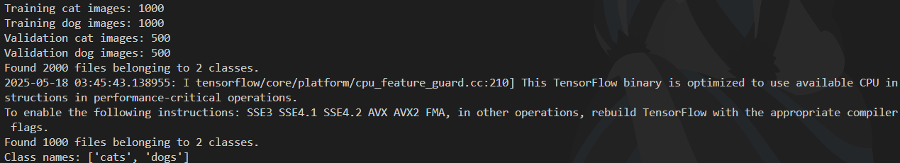

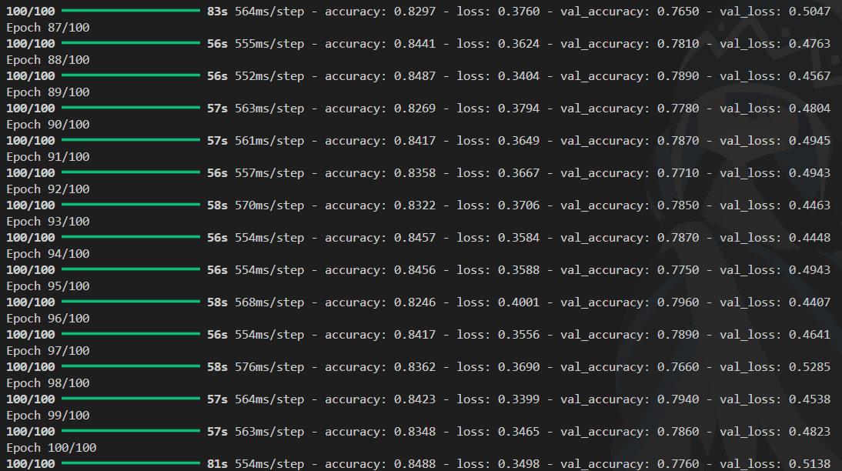

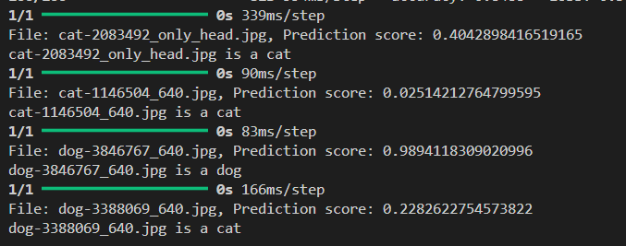

1. Listing 3.3. cats_and_dogs_classifier_with_transfer_learning.py

1. Listing 3.4. hand_sign_language_classifier.py

\

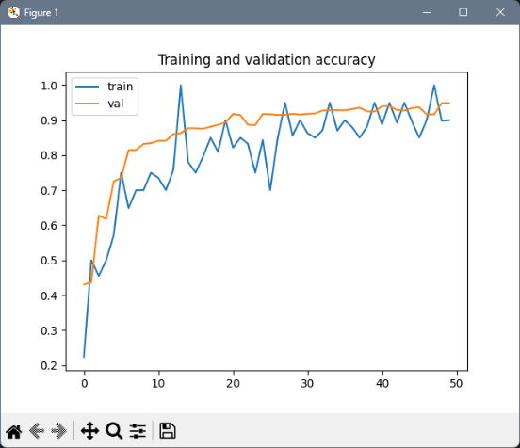

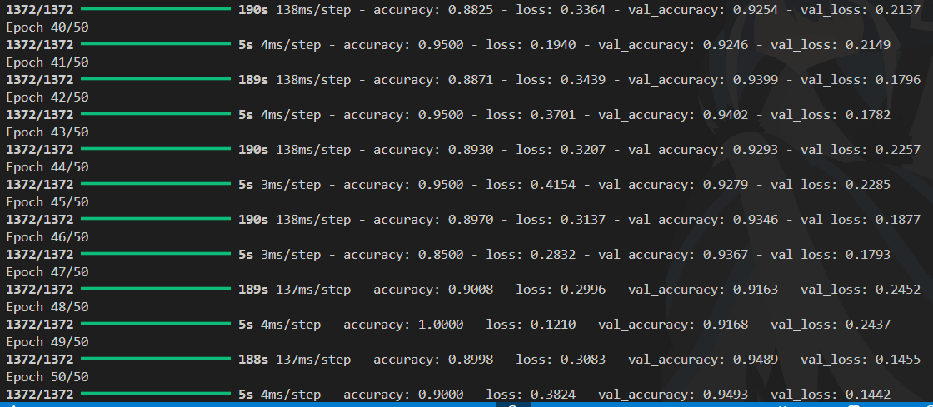

1. Analisa

Praktikum ini mencakup beberapa program klasifikasi menggunakan TensorFlow dengan berbagai dataset dan model yang berbeda. Program pertama adalah pelatihan model jaringan saraf tiruan sederhana pada dataset Fashion MNIST. Program ini menggunakan callback khusus untuk menghentikan pelatihan secara otomatis ketika akurasi sudah melebihi 60%, sehingga proses menjadi lebih efisien. Data gambar berukuran 28x28 piksel dinormalisasi agar piksel berada di rentang 0 hingga 1. Model dibangun dengan lapisan Flatten untuk mengubah input 2D menjadi 1D, diikuti Dense layer dengan 512 neuron dan aktivasi ReLU, serta output layer dengan 10 neuron menggunakan aktivasi softmax untuk klasifikasi multi-kelas. Model dilatih dengan optimizer Adam dan fungsi loss sparse_categorical_crossentropy selama maksimal 10 epoch, namun pelatihan bisa berhenti lebih awal sesuai callback.

Program kedua menggunakan arsitektur Convolutional Neural Network (CNN) untuk klasifikasi gambar Fashion MNIST. Setelah data dinormalisasi dan ditambahkan dimensi channel agar sesuai input CNN, model dibangun dengan dua lapisan Conv2D berfilter 64 ukuran 3x3, diikuti MaxPooling2D untuk mengurangi dimensi fitur. Selanjutnya data di-flatten dan dilanjutkan ke dense layer untuk klasifikasi. Program ini juga menyediakan fungsi visualisasi untuk memperlihatkan proses convolution dan max pooling pada lapisan awal, sehingga pengguna dapat memahami bagaimana fitur gambar diekstraksi oleh model.

Program ketiga fokus pada klasifikasi ekspresi wajah “happy” dan “sad” menggunakan CNN. Dataset wajah berlabel diekstrak dari file ZIP dan diproses dengan ImageDataGenerator untuk normalisasi serta pembagian data pelatihan dan validasi. Model CNN terdiri dari beberapa lapisan konvolusi dan pooling, lalu flatten dan dua dense layer, dengan output sigmoid untuk klasifikasi biner. Callback dipasang agar pelatihan berhenti ketika akurasi mencapai 99%. Setelah pelatihan selesai, model digunakan untuk memprediksi ekspresi pada gambar uji, dengan hasil prediksi dikategorikan berdasarkan threshold 0.5. Program juga menampilkan gambar sampel dari masing-masing kelas sebelum pelatihan.

Program keempat membangun model CNN untuk membedakan antara gambar kucing dan anjing. Dataset diekstrak dan dipisahkan menjadi data pelatihan dan validasi, lalu diproses menggunakan ImageDataGenerator untuk penskalaan piksel. Model CNN terdiri dari tiga lapisan konvolusi dan pooling, kemudian flatten dan dua dense layer, dengan aktivasi sigmoid pada output untuk klasifikasi biner. Selain melatih model, program ini juga memvisualisasikan grafik akurasi dan loss selama proses pelatihan serta menampilkan representasi feature map dari setiap lapisan CNN untuk memperlihatkan proses ekstraksi fitur.

Program kelima merupakan pengembangan dari program sebelumnya dengan penambahan augmentasi data seperti rotasi, zoom, dan flip horizontal untuk meningkatkan kemampuan model mengenali data baru dan mencegah overfitting. Gambar diresize menjadi 150x150 piksel dan diproses dalam batch berukuran 20. Model CNN yang digunakan juga memiliki lapisan dropout untuk mengurangi overfitting. Setelah pelatihan, akurasi dan loss divisualisasikan dan terdapat fungsi untuk menguji prediksi model pada gambar individual di luar dataset pelatihan.

Program keenam mengaplikasikan transfer learning dengan menggunakan model VGG16 tanpa top layer untuk klasifikasi kucing dan anjing. Dataset diproses menggunakan ImageDataGenerator dengan augmentasi opsional. Bobot model VGG16 yang sudah dilatih sebelumnya dimuat dan lapisan-lapisan awal dibekukan agar tidak ikut dilatih ulang. Di atas model tersebut ditambahkan lapisan dropout, flatten, dan dua dense layer dengan output sigmoid untuk klasifikasi biner. Model ini dilatih selama 20 epoch dan hasil pelatihan divisualisasikan dalam grafik. Tersedia juga fungsi untuk menguji model pada gambar baru dari folder tertentu.

Terakhir, program ketujuh mengimplementasikan klasifikasi huruf alfabet dari dataset Sign Language MNIST. Data diambil dari file CSV dan diolah menjadi gambar 28x28 piksel grayscale. Augmentasi data dilakukan untuk mengurangi risiko overfitting. Model CNN yang dibangun terdiri dari lapisan Conv2D, MaxPooling, Dropout, Flatten, dan dense layer dengan 26 neuron output dan fungsi aktivasi softmax untuk klasifikasi multi-kelas. Model dilatih selama 50 epoch dengan validasi, dan program menyediakan fungsi untuk mengklasifikasikan gambar eksternal serta menampilkan hasil prediksi huruf yang paling mungkin.

1. Kesimpulan

Kesimpulannya, praktikum ini memperlihatkan berbagai pendekatan dalam pembangunan model klasifikasi gambar menggunakan TensorFlow, mulai dari jaringan saraf tiruan sederhana hingga Convolutional Neural Network (CNN) yang lebih kompleks. Penggunaan callback untuk menghentikan pelatihan secara otomatis dan teknik augmentasi data terbukti efektif dalam meningkatkan efisiensi pelatihan serta kemampuan generalisasi model. Transfer learning dengan model VGG16 juga menunjukkan bagaimana pemanfaatan model pra-latih dapat mempercepat dan memperbaiki hasil klasifikasi. Seluruh program menekankan pentingnya preprocessing data, seperti normalisasi dan augmentasi, serta penggunaan arsitektur yang sesuai dengan jenis data dan tugas klasifikasi yang dihadapi.